Big Data Testing
Phases Of testing
1.Data Staging validation:
Data from various source like RDBMS, social media etc. should be validated to make sure correct data is loaded into system.
Comparing source data with data loaded into Hadoop system to make sure they are correct or matching.
Verify correct data is extracted and loaded into correct HDFS location.
2.Mapreduce/Hive/Pig validation
In this phase will verify the business logic validation on every node/script, it is running and working as per logic correctly.
3.Output validation
In this final phase complete output files are extracted as per the requirement and compared against source data.
Tools Used in Big data
- HDFS is used for storage
- Map reduce is for processing data
- Hive is for querying data
- Pig is processing and transforming data
- Sqoop is for ingesting data from RDBMS into HDFS
- Spark is used to Load the data into HDFS
- Splunk Dashboard is used to verify logs.

Test document
- SRS/BRS/FSD requirement Document (BA) / Design Document -Developer
- Mapping sheet – Source (DWH) to Target (Hadoop Tables)
- HLSD or DATA MODEL
Test Case scenarios
- Structure Validation
- Count Validation
- Data Validation
- Duplicate Validation
- Derived Column Validation

Test case Design
Writing test cases for the below nifi process
User Story Number: U127067

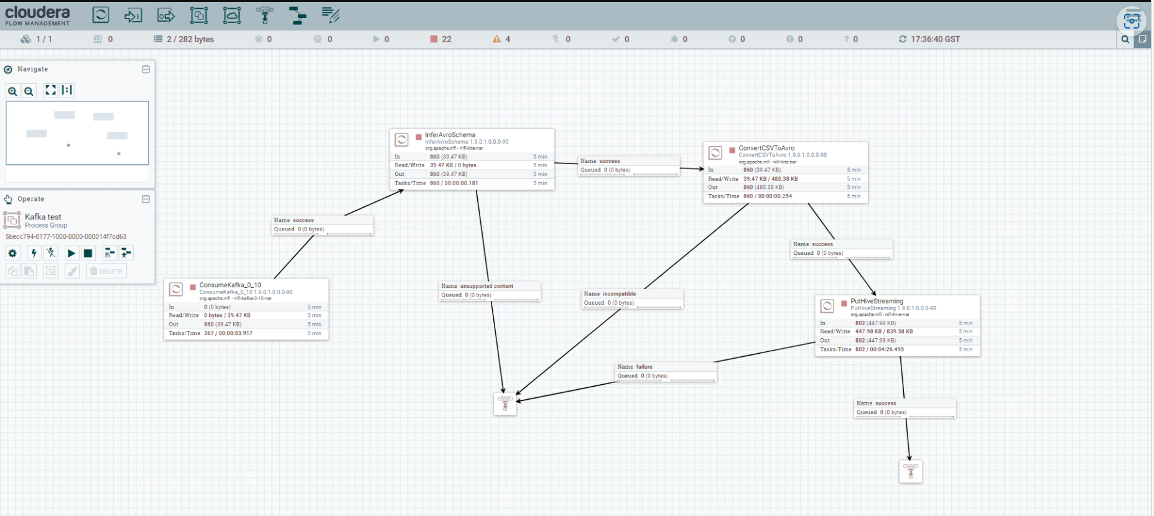

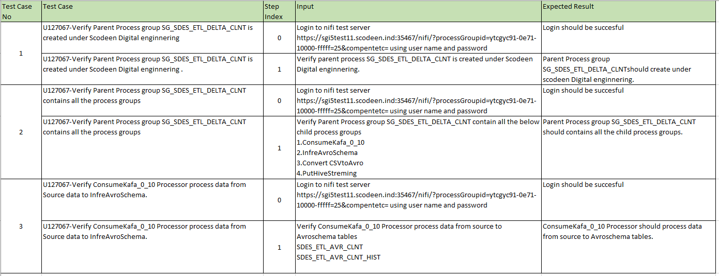

Roles and responsibilities
- Understanding the requirement (Analyzing SRS/BRS/FSD)
- Preparation of test estimation (Sr fellow in team or Team Lead)
- Test planning (Test Scenarios)
- Test Case Design
- Test case execution
- Defect reporting, Defect Retest.
- Daily Status report
- Test completion Report
- ETL tool testing at every stage while loading data using Sqoop/ flume.
- If you have extraction by using MapReduce then we need to test MapReduce Scripts.
- Validating Data in Hive tables after loading data from HDFS.

